**Lab 3 Tasks**

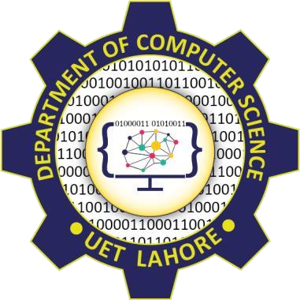

Session: 2022 – 2026

**Submitted by:**

Asim Ali Murtaza 2022-CS-175

**Supervised by:**

Mr.Nauman Shafi

Department of Computer Science

**University of Engineering and Technology**

**Lahore Pakistan**

**Lab Tasks**

**1:**

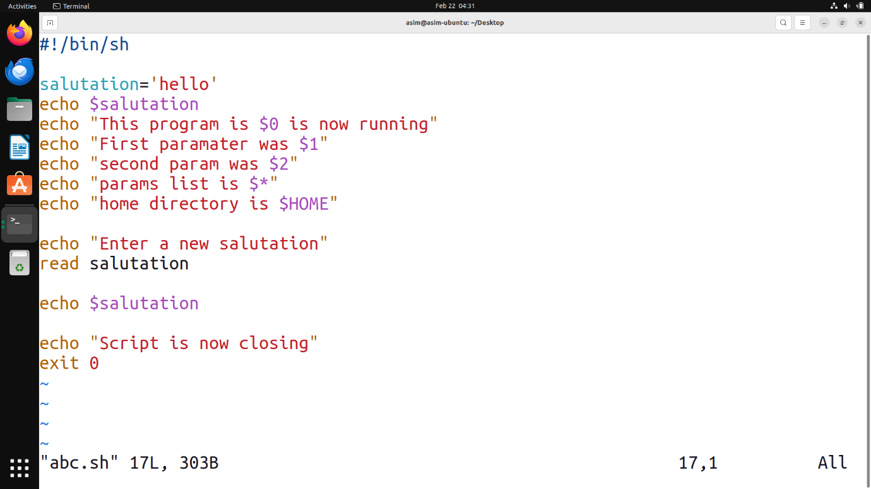

2:

3:

4:

5:

6:

7:

8:

